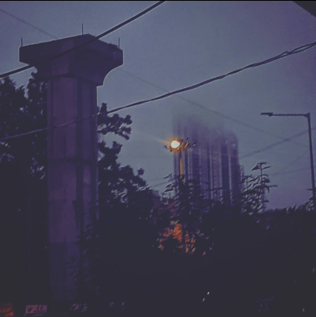
I don't know,
how many times,
have I said,
this is the last,
the last time I think,
the last time I,
force myself to breathe,
the last time,
I use the word,
love, hope, trust, and will,
the last time ,
I say this is the last time,
the last time,
I close a chapter,
but each time,
every word takes new meaning,
a new mental shape,
and oh how damned I am,
to constantly reconstruct,
my own sense of what,
I call something,
to be a last time,

because regardless,
of how much my mind asks for
a last time,

the heart says, once more,
for the better or worse.

